**ASSIGNMENTS ON DIGITAL MARKETING**

**NAME:** SABEEK RAHMAN S

**DEPARTMENT:** BE BIOMEDICAL ENGINEERING

**COLLEGE:** 8151 DHANALAKSHMI SRINIVASAN INSTITUTE OF

TECHNOLOGY

**NAANMUDHALVAN COURSE**: DIGITAL MARKETING

**NM ID:** 1DECD8D695A9C2A80D74D65C33875FD8

**ASSIGNMENT 1:**

Create a blog or website using Blogspot and WordPress. Customize

The theme design and post new article with 500 words.

<https://3starsoft.wordpress.com/2023/10/18/3star/>

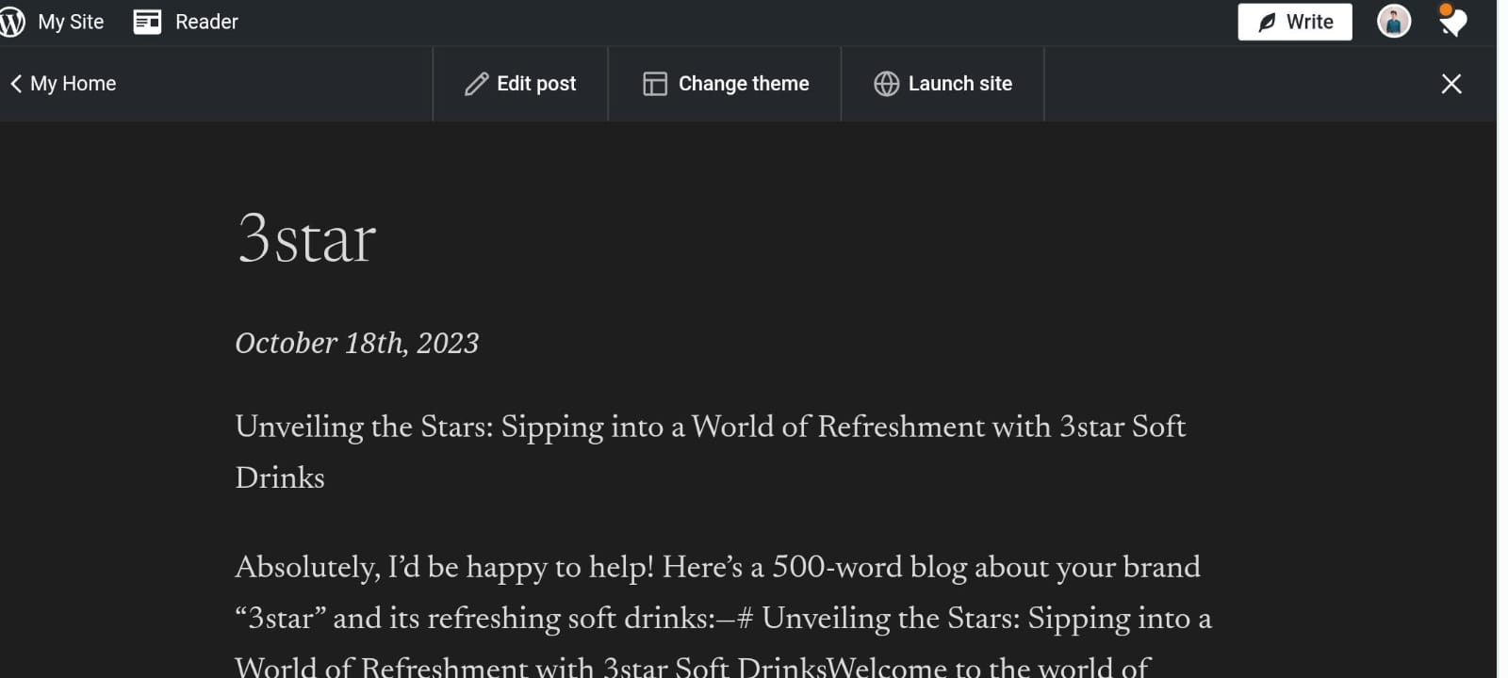

**ASSIGNMENT 2:**

Create a new Facebook business Page and Post one social media poster for your brand.

<https://www.facebook.com/profile.php?id=61552476544785&mibextid=ZbWKwL>

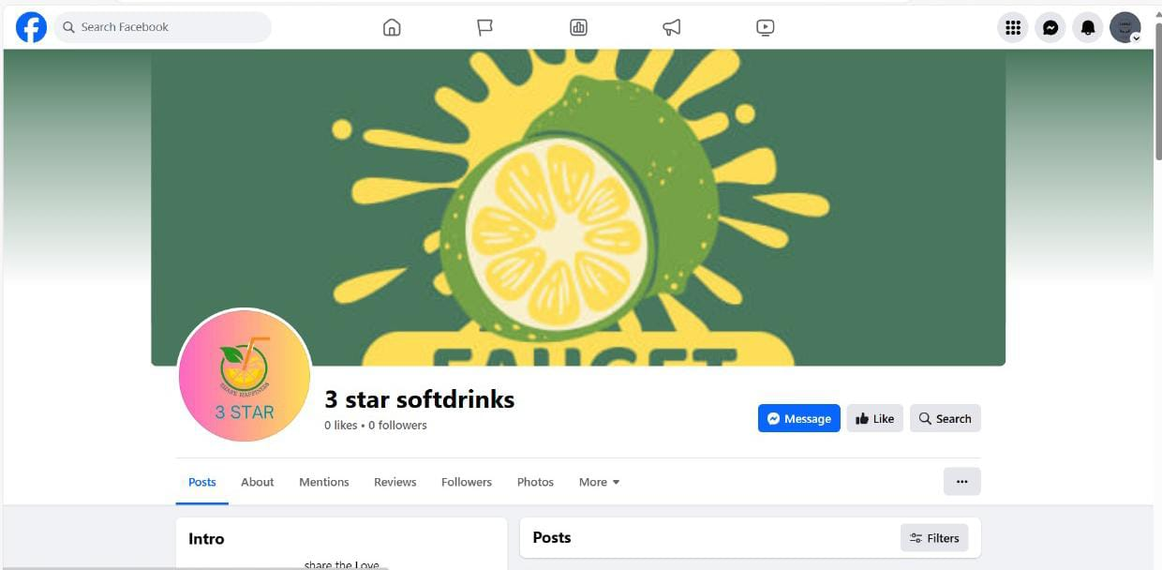

**ASSIGNMENT 3:**

Create and design a social media advertisement poster using Canva.

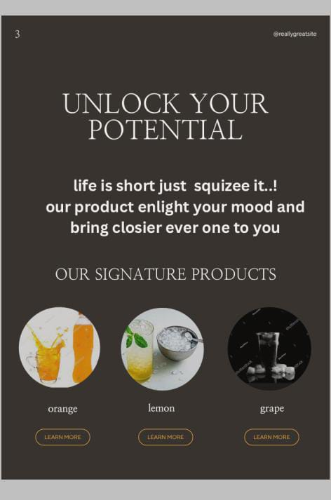

**ASSIGNMENT 4:**

4.Create email newsletter design using MailChimp or Canva tool.

